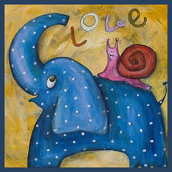

THE HARKINS WAY

Our CARING TOUCH –

- Each infant is wrapped in a blanket created just for your baby by one of our creative team members. We encourage you to hold the blanket, dry your tears, kiss it so your child is wrapped in your love and touch.
- Cremation urns or burial caskets are gifted as well. Your team members will discuss these options with you.
- Personalized memory cards are created for your baby as mementos for family and friends
- Harkins Funeral Home will prepare and file the necessary documents with the State Vital Records Division as well as cremation authorizations forms (if chosen)
- Harkins does have a Gone Too Soon plot in Slate Ridge Cemetery if burial is chosen. Your team can answer any questions if burial is your choice.
- Each mother receives a bag of items just for her to help feel loved and remembered by our program
- Funeral services are an option as well. Patti can discuss the details with you if you wish to hold a service.
WE WOULD LIKE TO THANK EVERYONE WHO CONTRIBUTES TO
THIS PROGRAM:

Evans Eagle Cremation Services of Leola, PA

Flowers by Fiore of Bel Air, MD

Slate Ridge Cemetery and Staff

Pastor Mark Rudd

Ladies who create blankets and the bags of comfort and strength

Many churches who support the program

Numerous people who donate to Gone Too Soon to help support this mission

Jeffrey Lovelidge, owner of Harkins Funeral Home.

Gone Too Soon is sponsored by
Harkins Funeral Home
600 Main Street, Delta, PA 17314

